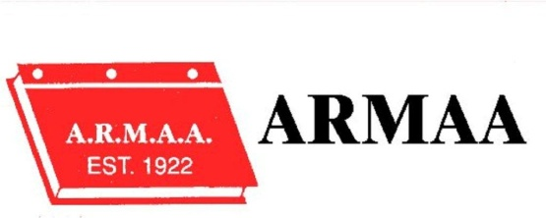

ALBERTA RURAL MUNICIPAL ADMINISTRATORS ASSOCIATION

2019 conference registration – Zone 2 – OLDS

GOLF TOURNAMENT: Wednesday, September 11, 2019 OLDS GOLF CLUB

Conference: September 11, 12 & 13, 2018 – POMEROY INN & SUITES

NAME: ________________________________________

MUNICIPALITY:_____________________________ EMAIL :_________________________________

WILL YOU BE ATTENDING THE BANQUET: _______ YES ______ NO

CONFERENCE REGISTRATION (MEMBERS) $150.00 $_______

NON MEMBER REGISTRATION $200.00 $_______

SPOUSE/PARTNER BANQUET ONLY $ 50.00 $_______

GOLF REGISTRATION $100.00 $_______

AVERAGE SCORE ON 18 HOLES: ______

SPOUSE GOLF SCORE ON 18 HOLES: ______ $100.00 $_______

AVERAGE SCORE ON 18 HOLES: ___________

NAME OF SPOUSE: _____________________________ ( GOLF TOURNAMENT)

GOLF BARBEQUE ONLY $25.00 $_______

TOTAL PAID : $_______
GST EXEMPT
Please note no refunds after August 8, 2019

PLEASE ENSURE YOUR REGISTRATION FORM IS SUBMITTED BY AUGUST 1, 2019

Special Dietary Needs or Allergies – Please list:

EMAIL your completed Registration Form to irenecoooper@xplornet.ca Mail your payment to:
ARMAA
Box 217
LA GLACE AB T0H 2J0

Questions may be directed to: irenecooper@xplornet.ca

ARMAA DOES NOT ACCEPT PAYMENT BY CREDIT CARD

2019 ARMAA CONFERENCE
SEPTEMBER 11TH TO 13TH

This year our annual Conference will be held in Olds at the Pomeroy Inn & Suites

The Golf Tournament will take place on the 11th at the Olds Golf Club. Breakfast will be served at the Golf Course prior to a Shotgun start at 9:00 a.m. (frost delay may be in effect)

The regular conference sessions start the morning of September 12th and the Conference will wrap up at noon on September 13th.

We have a block of rooms reserved at the Pomeroy Inn & Suites. This block will only be held until August 10, 2019, so it is important that you book your accommodations as early as possible.

Pomeroy Inn & Suites
4601-46 Ave
Olds AB
PHONE: 403-556-8815

IF THE POMEROY IS BOOKED, THERE IS A BLOCK OF ROOMS AT THE BEST WESTERN WHICH IS ACROSS FROM THE POMEROY:

Best Western
4520- 46 St.
Olds, AB
PHONE: 403-556-5900

PLEASE STATE THAT YOU ARE BOOKING FOR THE ARMAA CONFERENCE

If you have any questions concerning the conference, please contact me via email: irenecooper@xplornet.ca

Hope to see you in Olds.

