2019 ARMAA CONFERENCE

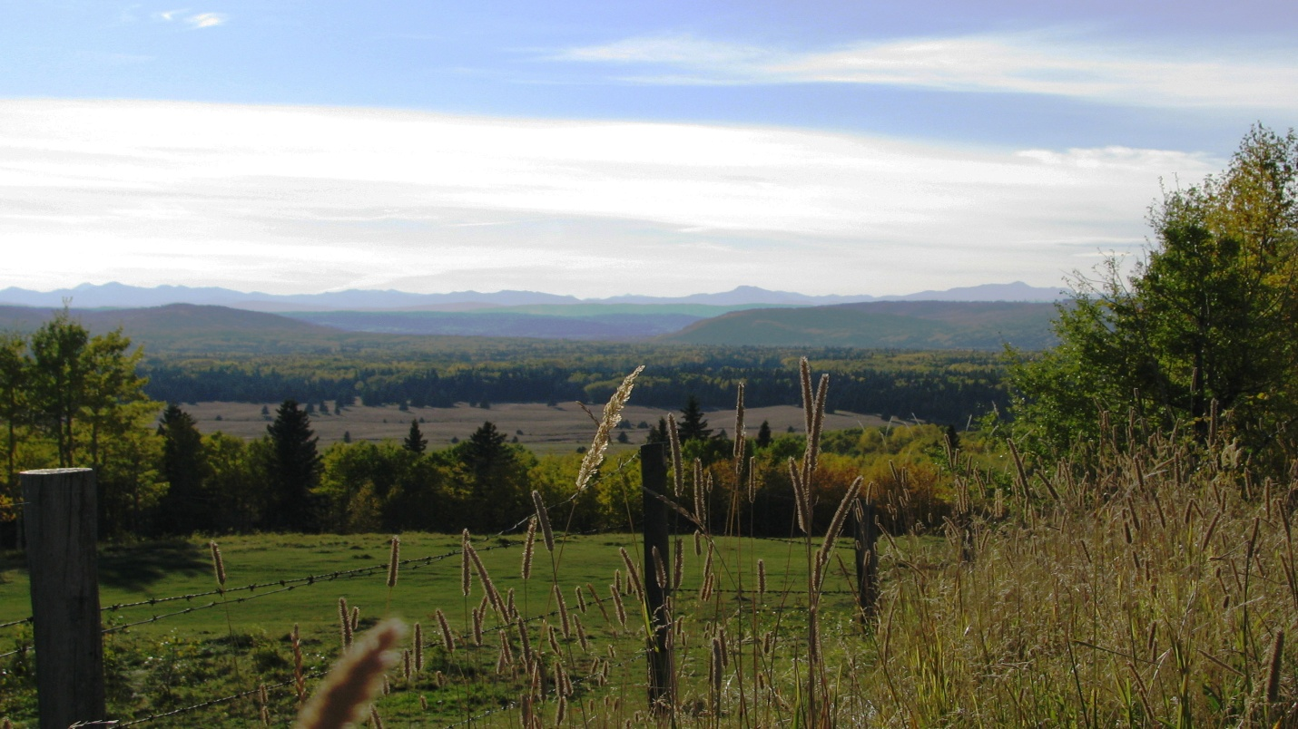

PHOTO BY MOUNTAIN VIEW COUNTY

OLDS ALBERTA

SEPTEMBER 11, 12 & 13

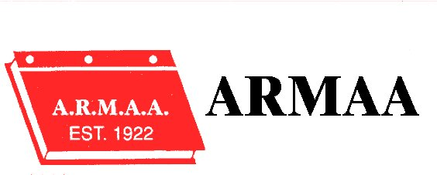

Our 2019 Conference will kick off with the Annual Golf Tournament, September 11th which will be held at the Olds Golf Course. Range Road 1, Highway 2 West.
Buffet Breakfast will be served from 7:30 a.m. to 8:30 a.m. in conjunction with Registration.

We do not have a bus service to the Golf Course.

Lunch will be sponsored by Kortech

We will wrap up with a barbeque sponsored by RMA and the awarding of prizes.

Social Evening & Registration (September 11th) will be held at the Olds Pomeroy from 6:30 p.m. – to 10:30 p.m. There will be finger foods and a cash bar. ARMAA will provide 1 drink ticket per registrant.

Olds Pomeroy will be the venue for the Conference, all meals are included in your registration commencing with breakfast on September 12th.

September 12, 2019

7:30 a.m. – 8:30 a.m. Registration & Breakfast

Session Chair President Cindy Vizzutti

8:30 – 9:00 a.m. Conference Opening

Greetings - Alberta Municipal Affairs
Greetings - Mayor, Town of Olds
Greetings – Reeve Bruce Beattie, Mountain View County

Introduction of New Members & Fraternal Delegates

Session Chair: Al Hoggan , Director Zone 2

9:00 – 9:30 a.m. R.M.A. – Gerald Rhodes & Tasha Blumenthal

9:30 – 10:00 a.m. Reynolds Mirth Richards & Farmer LLP – Kelsey Becker Brookes & Sean Ward.

Rural Urban Funding Agreements for Recreation Facilities & Liability Protection

10:00 – 10:30 a.m. Coffee Break

10:30 – 11:45 a.m. APEG Presentation – John Corriveau & Shauna Finlay
Licensed Professionals – Essential Partners for Success
(Critical legal, contractual and practical implications of using Engineering and Geoscience Professionals)

11:45 – 12:20 p.m. Lunch

Alberta Rural Municipal Administrators’ Association

September 12, 2019

12:20 pm – 2:30 pm Tour of Olds College Gardens, Composting Facility & Brewery

2:45 pm Coffee

2:45 pm – 3:15 pm Brownlee LLP - NFPA and OH&S Standards
Rural/ Urban Agreements

3:15 pm – 3:45 pm. MCCAC – Municipal Climate Change Action Centre
Grant Programs and Municipal Participation.

Session Chair President Cindy Vizzutti

3:45 pm – 4:00 p.m. Business Meeting – Nominations & Elections

Election of President and Vic President

District Meetings

- Nominations & Election of Directors for:
Districts : 2 & 4

Alberta Rural Municipal Administrators’ Association

September 12, 2019

6:00 – 6:30 p.m. Cash Bar

6:30 pm - Dinner (Buffet & Casual Evening)

Sponsored by RMRF

Member reports from Fraternal Conferences

Presentations to New Members

Presentations to Retiring Members

Entertainment

Alberta Rural Municipal Administrators’ Association

September 13, 2019

7:30 a.m. Breakfast

Session Chair Curtis Herzberg

8:30 am – 10:30 am Dialogue with Municipal Affairs.

10:30 a.m. to 11:00 a.m Open Discussion – ARMAA Direction

Session Chair Cindy Vizzutti

11:00 am – 11:30 am Annual General Meeting

Adoption of Minutes:
September 2018 Business Meeting
September 2018 Annual General Meeting

Financial Report December 31, 2018

President’s Report – Cindy Vizzutti

Municipal Health & Safety Association

New Business & Discussions

Location of 2020 Conference – Zone 3

Election Results

Results of District Elections

Adjournment – Safe travels home

