Director of Infrastructure Services
Municipal District of Bonnyville No. 87
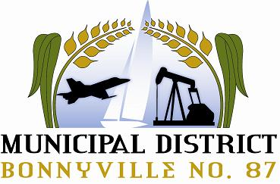
Bonnyville, Alberta

The Municipal District of Bonnyville is currently seeking a dynamic individual to fulfill the role of Director of Infrastructure Services.
Our rural community (www.md.bonnyville.ab.ca) is a thriving municipality in northeastern Alberta, 2.5 hours northeast of Edmonton. The M.D. has a fantastic community base of 12,000 residents, and an excellent, growing economy consisting largely of agriculture and oil-related industries.
Reporting to the CAO, the Director of Infrastructure Services is responsible for the direction, and coordination of the activities of the M.D. Infrastructure department. This position oversees three direct reports, 55 full-time staff, approximately 50 seasonal, and is responsible to manage an estimated annual budget of $40M.
The ideal candidate will possess a post-secondary education in Civil Engineering, Infrastructure Management or an equivalency in a related field as well as excellent leadership and proactive skills. Other duties include:
- Provide leadership, adapt and integrate complex manners to ensure a clear understanding of Council objectives are reached in consultation with the CAO.
- Provide recommendations to the CAO on the operating procedures required for fulfillment of municipal goals.
- Control and monitor operating and capital budgets for the department.
- Understand all relevant/applicable legislation and ensure the provisions of each are maintained.
- Possess knowledge in strategic planning, and organizational development.
- Provide the necessary skillset as an intricate member of the senior management team.
- Develop positive team relations that encourage staff engagement within the department.

A competitive salary and comprehensive benefits package is available. Specifics will be discussed in a personal interview.
All interested candidates are invited to submit their resume, in confidence to:
Email: hr@md.bonnyville.ab.ca
Please visit http://md.bonnyville.ab.ca/jobs.aspx for a full job description.

Competition Closing Date: February 15, 2019

