Chief Administrative Officer (CAO)
Municipal District of Bonnyville No. 87
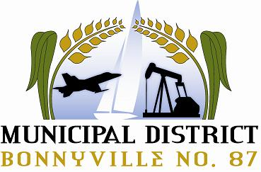
Bonnyville, Alberta

The Municipal District of Bonnyville is currently seeking a dynamic individual to fulfill the position of Chief Administrative Officer.
Our rural community (www.md.bonnyville.ab.ca) is a thriving municipality in northeastern Alberta, 2.5 hours northeast of Edmonton. The M.D. is rich in many things – a fantastic community base of over 13,000 residents, and an excellent, growing economy consisting largely of agriculture and oil-related industries.
Reporting to the Reeve and Council, the Chief Administrative Officer (CAO) is responsible for the overall administration of municipal operations and the daily tasks of the M.D., as directed by Council. He/she is responsible for directing, controlling and coordinating the activities of the M.D. departments which includes eleven direct reports and over 145 full-time staff, and a combined budget of over $136M.
The ideal candidate will possess a post-secondary education in Business Management, Public Administration, Land Use Planning and Development, or a relevant field of Engineering. The ideal candidate will also have Local Authority Administration Level I and Level II training and senior leadership experience. This includes:
- A demonstrated track record of senior management experience within a multi-dimensional service organization.
- A proven ability to provide leadership, and to adapt and integrate complex planning policy and program initiatives.
- A thorough understanding of the financial and budgeting process.
- An ability to work effectively with elected officials, community volunteers, boards and committees, industry partners, and public participation processes.
- An ability to work with staff and achieve positive outcomes.
- Proven experience in strategic planning, organizational development, and achieving results in building team relations.
- Working knowledge of the Alberta Municipal Government Act (MGA) is required.
- Operating knowledge of relevant technology.

A competitive salary and comprehensive benefits package is available. Specifics will be discussed in a personal interview.
Please visit http://md.bonnyville.ab.ca/jobs.aspx for a full job description.

All interested candidates are invited to submit their resume, in confidence to:
Reeve Greg Sawchuk
P.O. Bag 1010
4905-50 Ave.
Bonnyville, AB
T9N 2J7
E-Mail: gsawchuk@md.bonnyville.ab.ca

Competition Closing Date: July 20, 2018

