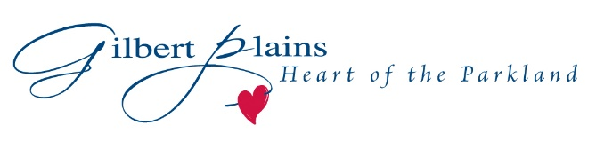
Chief Administrative Officer

The Council of Gilbert Plains Municipality, with the support of Way To Go Consulting Inc., is seeking an individual that will bring strong leadership, as well as strong communication and financial skills to this position.

Key responsibilities of this position include:
- Takes a key role in promoting and building the Municipality.
- Manages, develops, and leads a diverse municipal staff.
- Leads the development of a long-range plan for the operation and continued success of the Municipality.
- Plans, directs and coordinates the day-to-day activities required to implement the plan and achieve the goals and objectives approved by Council.
- Recommends new initiatives, programs, policies and plans for Council to consider.
- Develops and implements a process for preparation of annual capital and operating budgets.
- Provides responsible financial planning and management of a budget of over $5 million.
- Develops positive relationships and maintains open communication with all stakeholders and constituencies of interest to the Municipality.

Ideally, you will possess technical skills and experience in municipal administration, financial management and human resource management. Strong communication, analytical, and leadership skills are just some of the requirements of the position. Candidates who have post-secondary education in a relevant discipline bring an educational advantage to the position.

There will be opportunities to grow and enhance your skills by contributing to the advancement of the economic and community development of the Municipality. Further professional development will be offered in order to ensure your success.

Gilbert Plains Municipality is located in Manitoba’s Parkland, and provides numerous opportunities for the active or outdoor enthusiast.

The right candidate can expect a comprehensive salary and benefits package.

Individuals interested in this position should send a resume and cover letter by email to Ernie Epp, Way To Go Consulting Inc., to ernie.epp@waytogoconsultinginc.ca .

The selection committee intends to review applications as early as August 31, 2017, however, applications may continue to be accepted until the right candidate is found.

We thank all who apply and advise that only those selected for
further consideration will be contacted.

