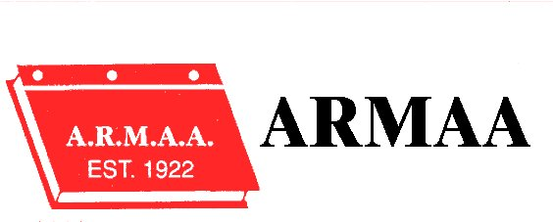

Alberta Rural Municipal Administrators’ Association

September 06, 2017

Golf Tournament

There will be bus transportation to and from the Golf Course from both the Best Western Plus Hotel & Casino and the Canalta. Pick up times will be posted in the hotel lobbies the evening of September 5th.

Social Evening

We will be hosting a Social Evening at the Best Western Plus Hotel & Casino from 6:30 p.m. to 10:00 p.m. the evening of September 6th. Registration for the Conference will take place at this time as well. Come and join your colleagues for refreshments and snacks.

Hospitality Room

ARMAA will host a Hospitality Room at the Best Western Plus Hotel & Casino September 5, 6, and 7th . Details will be posted in the Best Western Lobby

Transportation from the Canalta

Please note that ARMAA is not providing transportation from the Canalta to the Best Western.

Breakfast

Breakfast will be served at the Golf Course on September 6th and each morning of the Conference at the Best Western. This is included in the Registration and you do not require the Hotel Coupon.

Alberta Rural Municipal Administrators’ Association
KEEP CALM …… LEAD ON

2017 Annual Conference

Best Western Plus Hotel & Casino
CAMROSE
September 6 – 8, 2017

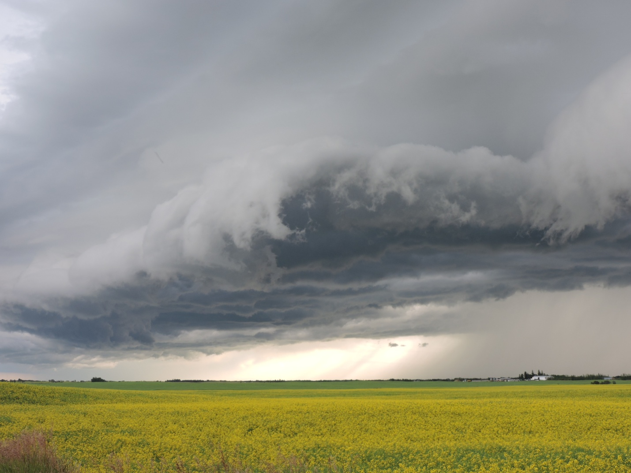
PHOTO COURTSEY OF CAMROSE COUNTY

Alberta Rural Municipal Administrators’ Association

September 07, 2017

Conference Theme: “ KEEP CALM … LEAD ON”

7:30 a.m. – 8:30 a.m. Registration & Breakfast

Session Chair President Rod Hawken

8:30 – 9:00 a.m. Conference Opening

In Memory of: Gary Popowich

Greetings - Alberta Municipal Affairs
Greetings – Reeve Don Gregorwich Camrose County
Greetings - Mayor - City of Camrose

Introduction of Fraternal Delegates

Fraternal Delegate - Saskatchewan – Guy Langrandeur
Fraternal Delegate - Manitoba
Fraternal Delegate - B.C.
SLGM –
LGAA – Michelle White

Session Chair: Al Hoggan , Director Zone 2

9:00 – 9:30 a.m. AAMDC –

9:30 – 10:00 a.m. Reynolds Mirth Richards & Farmer LLP –
Bill 17 – The Fair & Family Friendly Workplaces Act

Alberta Rural Municipal Administrators’ Association

September 07, 2017

10:00 – 10:30 a.m. Coffee Break

10:30 – 12:00 Keynote Speaker – Paul Huschilt

12:00 – 1:00 p.m. Lunch -

Session Chair Luc Mercier, Director Zone 3

1:00 pm – 2:30 p.m.
Discussions with Deputy Ministers
Departments to be confirmed

2:30 pm – 2:45 pm Coffee –

2:45 pm – 3:15 p.m. Brownlee LLP - Medical Marijuana & The Work Place
Colin Fetter

3:15 pm – 3:45 p.m. Brian Austrom – ICF Process

Session Chair President Rod Hawken

3:45 pm – 4:00 p.m. Business Meeting – Nominations & Elections
Nominations for President
Nominations for Vice President
District Meetings

- Nominations & Election of Directors for:
Districts : 2 & 4

Alberta Rural Municipal Administrators’ Association

September 07, 2017

6:00 – 6:30 p.m. Cash Bar

6:30 pm - Banquet

Sponsored by Reynolds Mirth Richards & Farmer LLP

Member reports from Fraternal Conferences

Introduction of Interns

Introductions of Fraternal Delegates

Presentations to New Members

Presentations to Retiring Members

Alberta Rural Municipal Administrators’ Association

September 08, 2017

7:30 a.m. Breakfast –

Session Chair Vice President Cindy Vizzutti

8:30 am – 11:00 am Municipal Affairs

Session Chair President Rod Hawken

11:00 am – 11:30 am Annual General Meeting

Adoption of Minutes:
September Business Meeting
September Annual General Meeting

Financial Report December 31, 2016
(Hand out at the Conference)

President’s Report – Rod Hawken

Municipal Health & Safety Association

New Business & Discussions

Location of 2018 Conference – Zone One

Election Results

Results of District Elections

Adjournment

CONFERENCE NOTES

