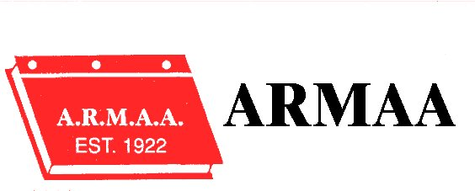
Alberta Rural Municipal Administrators’ Association
KEEP CALM …… LEAD ON
2017 Annual Conference
Best Western Plus Hotel & Casino
CAMROSE
September 6 – 8, 2017

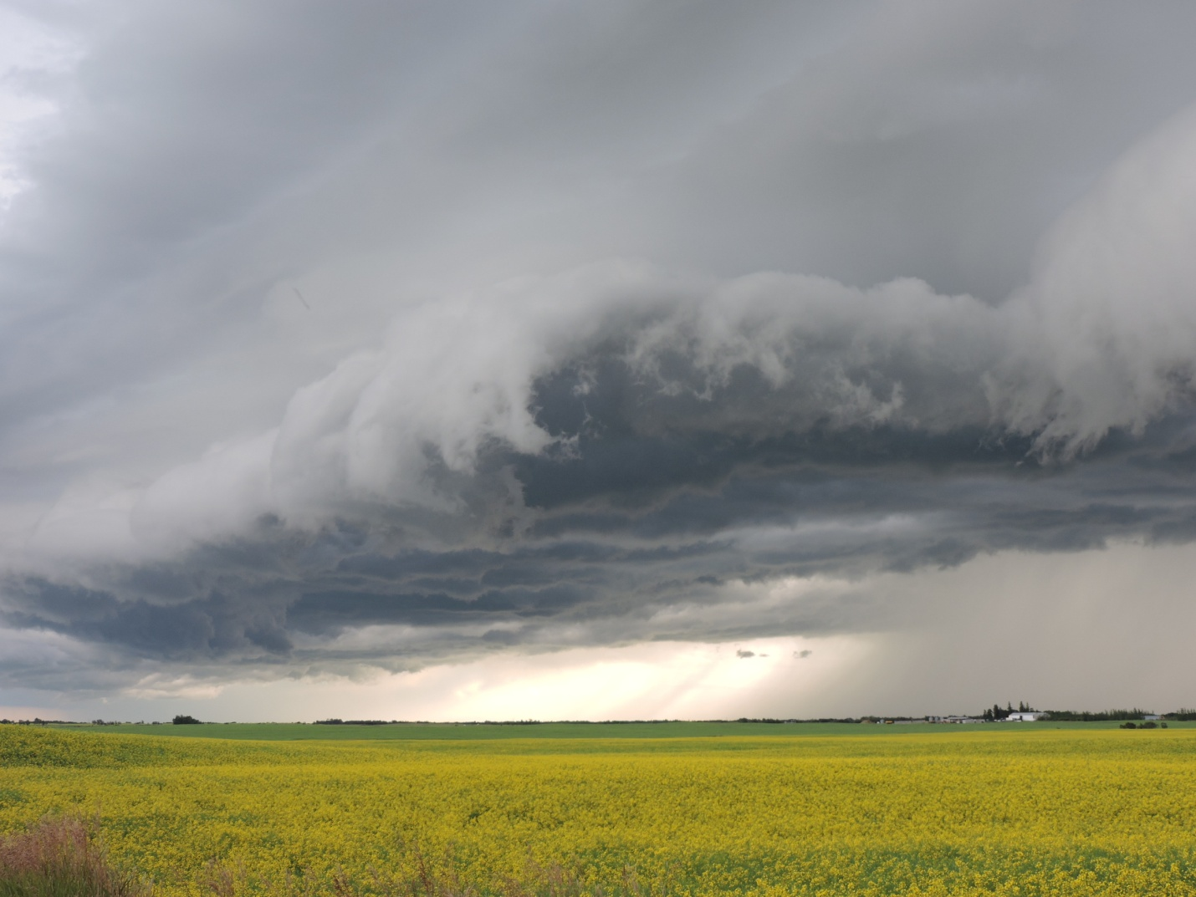
PHOTO COURTESY OF CAMROSE COUNTY

Alberta Rural Municipal Administrators’ Association

September 06, 2017

Golf Tournament

There will be bus transportation to and from the Golf Course from both the Best Western Plus Hotel & Casino and the Canalta. Pick up times will be posted in the hotel lobbies the evening of September 5th.

Social Evening

We will be hosting a Social Evening at the Best Western Plus Hotel & Casino from 6:30 p.m. to 10:00 p.m. the evening of September 6th. Registration for the Conference will take place at this time as well. Come and join your colleagues for refreshments and snacks.

Hospitality Room

ARMAA will host a Hospitality Room at the Best Western Plus Hotel & Casino September 5, 6, and 7th . Details will be posted in the Best Western Lobby

Transportation from the Canalta

Please note that ARMAA is not providing transportation from the Canalta to the Best Western.

Breakfast

Breakfast will be served at the Golf Course on September 6th and each morning of the Conference at the Best Western. This is included in the Registration and you do not require the Hotel Coupon.

Alberta Rural Municipal Administrators’ Association

September 07, 2017

Conference Theme: “ KEEP CALM … LEAD ON”

7:30 a.m. – 8:30 a.m. Registration & Breakfast

Session Chair President Rod Hawken

8:30 – 9:00 a.m. Conference Opening

In Memory of: Gary Popowich

Greetings - Alberta Municipal Affairs
Greetings – Reeve Don Gregorwich Camrose County
Greetings - Mayor - City of Camrose

Introduction of Fraternal Delegates

Fraternal Delegate - Saskatchewan – Guy Langrandeur
Fraternal Delegate - Manitoba - Dale Toews
Fraternal Delegate - B.C.
SLGM –
LGAA – Michelle White

Session Chair: Al Hoggan , Director Zone 2

9:00 – 9:30 a.m. AAMDC –

9:30 – 10:00 a.m. Reynolds Mirth Richards & Farmer LLP –
Bill 17 – The Fair & Family Friendly Workplaces Act

Alberta Rural Municipal Administrators’ Association

September 07, 2017

10:00 – 10:30 a.m. Coffee Break

10:30 – 12:00 Keynote Speaker – Paul Huschilt

12:00 – 1:00 p.m. Lunch

Session Chair Luc Mercier, Director Zone 3

1:00 pm – 2:30 p.m.
Discussions with Deputy Ministers
Municipal Affairs, Transportation and Solicitor General

2:30 pm – 2:45 pm Coffee

2:45 pm – 3:15 p.m. Brownlee LLP - Medical Marijuana & The Work Place
Colin Fetter

3:15 pm – 3:45 p.m. Brian Austrom – ICF Process

Session Chair President Rod Hawken

3:45 pm – 4:00 p.m. Business Meeting – Nominations & Elections
Nominations for President
Nominations for Vice President
District Meetings

- Nominations & Election of Directors for:
Districts : 2 & 4

Alberta Rural Municipal Administrators’ Association

September 07, 2017

6:00 – 6:30 p.m. Cash Bar

6:30 pm - Banquet

Sponsored by Reynolds Mirth Richards & Farmer LLP

Member reports from Fraternal Conferences

Introduction of Interns

Introductions of Fraternal Delegates

Presentations to New Members

Presentations to Retiring Members

Alberta Rural Municipal Administrators’ Association

September 08, 2017

7:30 a.m. Breakfast –

Session Chair Vice President Cindy Vizzutti

8:30 am – 11:00 am Municipal Affairs

Session Chair President Rod Hawken

11:00 am – 11:30 am Annual General Meeting

Adoption of Minutes:
September Business Meeting
September Annual General Meeting

Financial Report December 31, 2016
(Hand out at the Conference)

President’s Report – Rod Hawken

Municipal Health & Safety Association

New Business & Discussions

Location of 2018 Conference – Zone One

Election Results

Results of District Elections

Adjournment

CONFERENCE NOTES

Financial Statements of
ALBERTA RURAL MUNICIPAL ADMINISTRATORS ASSOCIATION
December 31, 2016

REVIEW REPORT
In accordance with the Alberta Rural Municipal Administrators Association (ARMAA) Constitution and Bylaws, we have reviewed the financial statements as at December 31, 2016.
In our opinion, these financial statements present fairly, in all material respects, the financial position of the association.
Original Signed |  |  |  |  | Original Signed
Cheryl McRae |  |  |  |  | Mike Morton
ARMAA Member |  |  |  |  | ARMAA Member
County of Two Hills |  |  |  |  | Kneehill County
Dated: | 17/07/17

Alberta Rural Municipal Administrators' Association
Income Statement
December 31, 2016
 |  | 2016 |  | 2015
REVENUE
 | Grants | $ 10,000 |  | $ 5,000
 | Career marketing strategy | - |  | -
 | Membership fees | 20,650 |  | 21,225
 | Conference fees | 11,963 |  | 35,230
 | Conference donations | 29,250 |  | 20,040
 | Golf fees | 4,875 |  | 5,975
 | Golf donations | 17,630 |  | 21,619
 | Interest and dividends | 312 |  | 370
 | Miscellaneous | 800 |  | 2,450
 |  | 95,479 |  | 111,909
EXPENSES
 | Annual conference | 33,990 |  | 30,595
 | Golf tournament | 21,314 |  | 20,271
 | Special projects | 5,003 |  | 1,366
 | Executive committee | - |  | 11,155
 | Management expense | 16,200 |  | 16,800
 | Meetings and conferences | 7,452 |  | -
 | Insurance | 694 |  | 890
 | Audit | - |  | -
 | Bank charges & interest | - |  | -
 | Bad debts expense | - |  | -
 | Stationary & supplies | 332 |  | 1,659
 | Telephone, postage & miscellaneous | 4,370 |  | 192
 | Deferred expense | - |  | -
 | Charitable Donation | - |  | -
 |  | 89,354 |  | 82,926
 |  | 6,126 |  | 28,983

Alberta Rural Municipal Administrators' Association
Balance Sheet
December 31, 2016
 |  | 2016 |  | 2015
ASSETS
 | Cash | $ 136,570 |  | $ 126,668
 | Accounts receivable | 2,350 |  | 5,700
 | Prepaid expenses | 639 |  | 1,066
 |  | 139,559 |  | 133,434
LIABILITIES
 | Accounts payable | 0 |  | 0
 | Deferred revenue | 0 |  | 0
 |  | 0 |  | 0
EQUITY
 | Beginning balance | 133,434 |  | 104,451
 | Prior Period Adjustment | 0 |  | 0
 | Surplus/(deficit) | 6,126 |  | 28,983
 | Ending balance | 139,559 |  | 133,434
 |  | 139,559 |  | 133,434

Alberta Rural Municipal Administrators' Association
Statement of Changes in Financial Position
December 31, 2016
 |  | 2016 |  | 2015
Cash from operations:
 | Net income | $ 6,126 |  | $ 28,983
 | (Increase)/decrease in accounts receivable | 3,350 |  | -582
 | (Increase)/decrease in prepaid expense | 426 |  | -289
 | Increase/(decrease) in accounts payable | 0 |  | -932
 | Increase/(decrease) in deferred revenue | 0 |  | 0
 | Increase/(decrease) in prior period revenue | 0 |  | 0
 |  | 9,902 |  | 27,179
Cash at beginning of year |  | 126,668 |  | 99,489
Cash at end of year |  | 136,570 |  | 126,668
Increase (Decrease) in cash account |  | 9,902 |  | 27,179

Alberta Rural Municipal Administrators' Association
Notes to the Financial Statements
December 31, 2016
Scope of Operations
The Alberta Rural Municipal Administrators Association was founded in 1922 as a fraternal organization which brings
the senior administrative staff of Alberta's rural municipalities for the purpose of improving the profession service
delivery to all Albertans. Objects of the association include working with other organizations to the betterment of
all branches of municipal government; protecting the interests of councils of Alberta's rural municipalities; mutual
assistance amongst members in resolving issues arising from legislation; promoting professionalism, educational
standards, and professional development; and obtaining recognition of the importance and responsibility of rural
municipal administrators. The association is exempt from income tax.
Basis of Accounting
The financial statements are prepared using the accrual basis of accounting. Expenses are recognized as they are
incurred and are measurable based on the receipt of goods or services and/or the legal obligation to pay.
Revenues are accounted for in the period in which the transactions or events that gave rise to the revenues.
Prepaid expenses
Prepaid expenses represent insurance and the deposits provided to secure conference and related facilities.

ALBERTA RURAL MUNICIPAL ADMINISTRATORS ASSOCIATION

BUSINESS MEETING

SEPTEMBER 08, 2016

The Business meeting was called to order at 3:45 p.m. on September 08, 2016 at the Pomeroy Hotel & Conference Centre, Grande Prairie, Alberta.

President Rod Hawken outlined sections of the ARMAA Bylaw as it pertained to the Election of Officers. The required 25% of the membership was present for the meeting.

ZONE DIRECTOR ELECTIONS

Rod Hawken announced that Zone Meetings will be held for elections in Zones 1, 3 and 5.

The Business Meeting was adjourned at 3:47 p.m.

Alberta Rural Municipal Administrators’ Association
Annual General Meeting
September 09, 2016

The Annual General Meeting was called to order at 11:00 a.m. at the Pomeroy Hotel & Conference Centre in Grande Prairie, Alberta. It was noted that a quorum of the membership was in attendance.

ADOPTION OF MINUTES – Annual General Meeting

Moved by Frank Coutney that the Minutes of the September 10, 2015 Annual General Meeting be adopted as circulated.

Carried
ADOPTION OF MINUTES - Business Meeting

Moved by Frank Coutney that the Minutes of the September 09, 2015 Business Meeting be approved as circulated.
Carried

ADOPTION OF FINANCIAL STATEMENT

Moved by Leo Ludwig that the Financial Statement for year ending December 31, 2015 be approved, as presented.
Carried

PRESIDENTS REPORT

Rod Hawken gave his report for the year.
Moved by Al Hoggan that the Presidents Report for 2015 be adopted for information.
Carried

MUNICIPAL HEALTH AND SAFETY REPORT

Moved by Terry Hager that the 2016 Municipal Health and Safety Report as submitted by Charlie Cutforth be accepted for information.

Carried

Alberta Rural Municipal Administrators’ Association
Annual General Meeting
September 09, 2016

ARMAA STRATEGIC PLAN

Moved by Frank Coutney that the ARMAA Strategic Plan be adopted as presented.

Carried.

2017 ARMAA CONFERENCE AND ANNUAL GENERAL MEETING

The 2017 ARMAA Conference & Annual General Meeting will be held September 6 to 8th in Camrose with the golf tournament being held at the Camrose Golf & Country Club

2016/2017 ARMAA EXECUTIVE

Rod Hawken President (2015 – 2017)
Cindy Vizzutti Vice President (2015 – 2017)
Director Zone 1 Doug Henderson (2016 – 2018)
Director Zone 2 Al Hoggan (2015 – 2017)
Director Zone 3 Luc Mercier (2016 – 2018)
Director Zone 4 Peter Thomas ( 2015 - 2107)
Director Zone 5 Tyler Lawrason (2016 - 2018)

Adjournment

The Annual General Meeting was adjourned at 11:37 a.m.

______________________________ _________________________________
President, Rod Hawken Executive Director, I Cooper

President’s Report – 2017

Stay Calm, Lead On – what a fitting theme for this years’ conference. Major changes in both the Federal and Provincial governments have required our municipalities to review current and future directions. We are in the midst of a major review of the Municipal Government Act (MGA) and nearly 60 regulations that need to follow. The timeline for these amendments remains very aggressive and as such the board and membership have been attending and reviewing many draft versions of the MGA amendments. The Friday session with Municipal Affairs “Regulations, the devil is in the details” will give members the opportunity to not only provide input to their development, but also to hear of experiences from all of our areas.

Your members have been very busy this year with the Municipal Sustainability Strategy (MSS) Viability reviews. At the time of writing this report there were 14 reviews begin undertaken. The Minister has put a moratorium on meetings until after the 2017 election.

There are a number of other committees that your executive and members have been appointed to. Thank you to all who have volunteered your time to help with the committee work.

The 5 year strategic plan was reviewed and passed at the 2016 annual meeting. Attached to my report is a scorecard relating to the plan to ensure the Vision, Goals and Strategies are on track.

A big thank you goes out to anyone who helped with the conference and to Martin Buckley and his golf committee.

I would also like to acknowledge Irene Cooper, Executive Director of your association. Irene has spent countless hours preparing for board meetings, arranging members to attend provincial committee meetings and of course this great conference. Thank you Irene.

To the membership, thank you for allowing me the opportunity to serve as your President for the past 2 years. Since 1922 there have been many great people serve on the executive and I can confidently say that there will be many more in the years to come. Happy 95th ARMAA.

Stay Calm!
Lead On!

Rod Hawken
President

