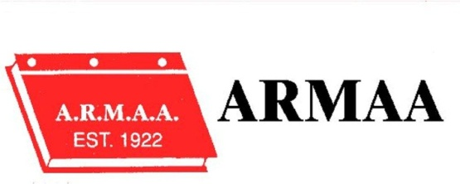

ALBERTA RURAL MUNICIPAL ADMINISTRATORS ASSOCIATION

2017 conference registration – Zone 5 – camrose

GOLF TOURNAMENT: Wednesday, September 6, 2017 CAMROSE GOLF & COUNTRY Club

Conference: September 7 & 8, 2016 – BEST WESTERN PLUS HOTEL & CASINO
3201-48 Avenue
NAME: ________________________________________

MUNICIPALITY:_____________________________ EMAIL :_________________________________

WILL YOU BE ATTENDING THE BANQUET: _______ YES ______ NO

CONFERENCE REGISTRATION $150.00 $_______

SPOUSE $ 50.00 $_______

GOLF REGISTRATION $100.00 $_______

AVERAGE SCORE ON 18 HOLES: ______

SPOUSE: $100.00 $_______

AVERAGE SCORE ON 18 HOLES: ______

NAME OF SPOUSE: _____________________________ ( IF ATTENDING THE CONFERENCE OR GOLF TOURNAMENT)

GOLF BARBEQUE ONLY $25.00 $_______

TOTAL PAID : $_______
DO NOT ADD GST
Please note no refunds after August 15, 2017
Special Dietary Needs or Allergies – Please list:

Send your completed Registration Form and payment to:
ARMAA
Box 217
LA GLACE AB T0H 2J0

Questions may be directed to: irenecooper@xplornet.ca

ARMAA DOES NOT ACCEPT PAYMENT BY CREDIT CARD

2017 ARMAA CONFERENCE
SEPTEMBER 6TH TO 8TH

This year our annual Conference will be held in Camrose at the Best Western Plus Resort and Casino in Camrose. The Golf Tournament will take place on the 6th, with the regular conference sessions starting the morning of September 7th and wrapping up at noon on September 8th.

We have a block of 70 rooms reserved at the Best Western Resort and Casino, and a block of 30 rooms booked at the Canalta in Camrose. These blocks will only be held until one month prior to the conference so it is important that you book your accommodations as early as possible. Please note that we will not have bus transportation from the Canalta to the Best Western.

BEST WESTERN PLUS CAMROSE
HOTEL & CASINO
3201-48 AVE
780-679-2376

CANALTA CAMROSE
4710-73 STREET
780-672-7303

If you have any questions concerning the conference, please contact me via email: irenecooper@xplornet.ca

Hope to see you in Camrose.

