For Immediate Release September 22, 2015

ALBERTA RURAL MUNICIPAL ADMINISTRATORS’ ASSOCIATION (ARMAA) PROVIDE CHARITABLE DONATION TO WETASKIWIN’S HORIZONS CENTRE

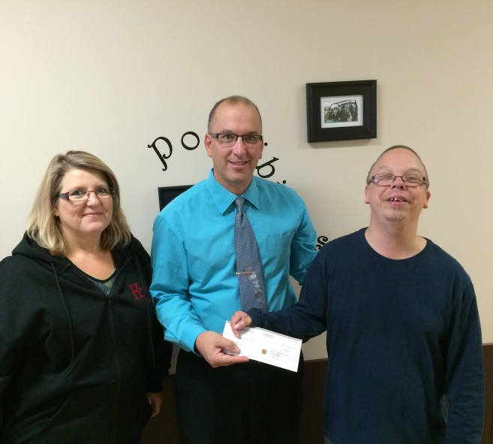
ARMAA President Rod Hawken (middle) presents a cheque for $920.00 to the Horizons Centre’s Kristin Lasell (right) that recognize the charitable contributions made by ARMAA. ARMAA is comprised of senior-level administrators employed within rural municipalities across Alberta and was founded in 1922. Pictured also is Kathy McKinney, Executive Director of the Horizons Centre.

During their annual Conference and Tradeshow held in Wetaskiwin from September 9-11, the Alberta Rural Municipal Administrators’ Association (ARMAA) raised money throughout the variety of events held during the three day conference. As has been ARMAA tradition for numerous years, funds raised are donated back to a local charitable organization within the host municipality.

This year, the Horizons Centre in Wetaskiwin has been selected as the recipient of the charitable funds raised by ARMAA Members totaling $920.00. The Horizons Centre is a prominent and provincially recognized organization that supports people with disabilities and their families with accountable services, while additionally maximizing the abilities of people with disabilities through quality service.

Rod Hawken, ARMAA President, stated that, “For many years, ARMAA has believed in giving back to the communities that has provided our organization to host our annual conference. With this monetary donation to the Horizons Centre, we are hopeful that people with disabilities and their families will be able to further benefit from the outstanding services that the Horizons Centre has provided for many decades.”

Established in 1922, ARMAA is an organization whose membership is comprised of senior-level administrators from rural municipalities that advocate the interests of municipal government from an administrative perspective and advance the interests of Alberta municipalities through networking, sharing resources, and other educational and informational sessions.

For more information on ARMAA, please refer to ARMAA’s website at www.armaa.ca.

- 30 -

For further information:
Rod Hawken, ARMAA President 780-361-6225 rhawken@county.wetaskiwin.ab.ca

